Annie Ballew, Network Consulting Engineer, Cisco Systems
Annie Ballew is a Network Consulting Engineer for the Worldwide Security Services Practice (WWSSP) at Cisco Systems.
Annie has been with Cisco for six years, initially as a support engineer in Cisco’s Technical Assistance Center and eventually transitioning into her current role as a consulting engineer specializing in network security. She completed her undergraduate education at the University of California, Berkeley with a degree in Electrical Engineering in 2004 and is recently graduated from the Northwestern MSIT program last year.
Annie’s certifications include the Cisco Certified Internetwork Expert (CCIE #18183) in Security and a CISSP.

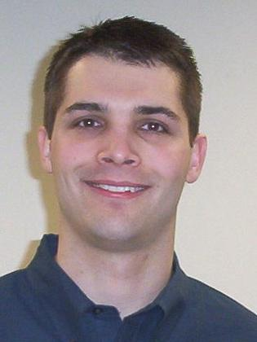
Larry Edie, Manager, Cisco Systems
Larry Edie manages delivery for the US Central Worldwide Security Services Practice (WWSSP). Larry works with his team to ensure high levels of success and customer satisfaction for projects in his region.
Larry has been with Cisco for five (5) years, consisting of two (2) years as a manager and three (3) prior years a Network Consulting Engineer (NCE). Overall, he has fourteen (15) years experience in the IT field and has been in security consulting for the last nine (9) years. While working as a NCE Larry did design and deployment services for most of the products in the Cisco security portfolio. He also assessed customer network security architectures as part of the Security Architecture Assessment (SAA) for large enterprises and service providers around the world.
Prior to joining Cisco, Larry held security consulting positions at Martin Progressive and Vanco Networks. His certifications include Cisco Certified Internetwork Expert (CCIE #20000) and CISSP.

