Image Spam Hunter 0.8
Yan Gao, Ming Yang, Xiaonan Zhao
EECS Dept., Northwestern Univ.
{y-gao2,m-yang4,xiaonan-zhao}@northwestern.edu

Purpose: Test the cross-validation performance on spam and normal image classification.
Features:
- : Open a sample image description file.
- : Save current sample images to a description file.
- : Enumerate .JPG files in a folder.
- : Load the images in the open folder to left list view.
- : Generate the training and testing sets.
- : Extract color and gradient orientation histogram for current image.
- : Extract color and gradient orientation histogram for all image in training set.
- : Train probabilistic boosting tree for color and gradient features.
- : Open and test one image.
- : Test the classification performance on the test set.
- : Perform 5-fold cross-validation on the sample image set.
- Left list view to display all sample images
- Right list view to display training images before training and the error images after testing.
- Bottom-right box to display the intermediate messages.
- Double-click on a file name to show the image.
- 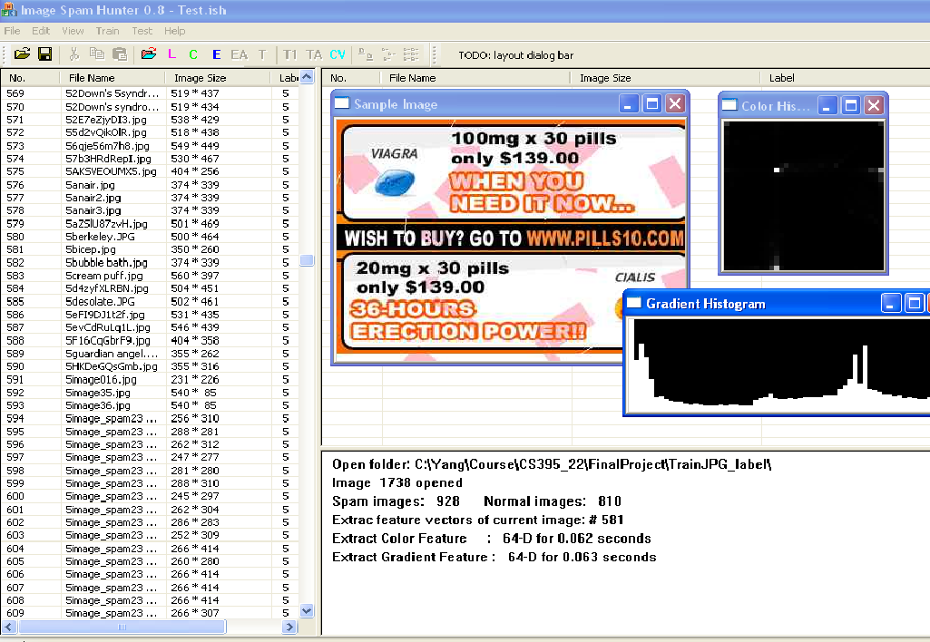Click on the list view column headers to sort the image.

